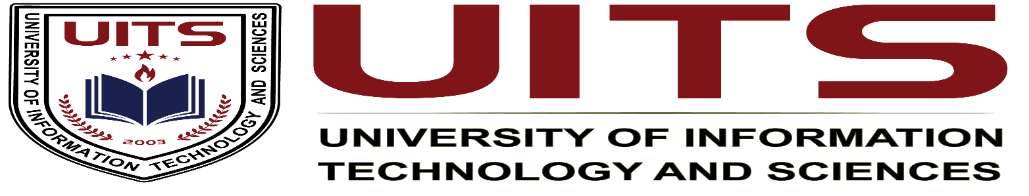lication Design

**Course Name :** Industrial Attachment

**Course Code :** CSE 420

**Student Name :** Md Shariful islam sajib sarker

**Student ID :** 2125051016

**Batch :** 50

**Section :** 7A1

**Semester :** Autumn

**Seminar Topic :** Navigating The Future of Software Industry

**Keynote Speaker :** Abdullah Al Hasan, Technical Lead, Brain Station 23

ion :Date of Submission :

**Navigating The Future of the Software Industry**

**Introduction :**

Seminar on "Navigating The Future of the Software Industry" aimed at providing a platform for discussing emerging trends, challenges and opportunities in software industry. Given this fast-changing landscape of rapidly changing technology. The seminar is focoused on giving advice regarding how the future of software development is and what professional skills are required to succeed in this fast-changing field.

**Keynote Speaker :**

Abdullah Al Hasan on Behalf of Brain Station 23 (Leading Software development company). He has years of experience working in the software industry and has led various successful software projects . His knowledge in Software development have made him an enriching speaker for the event.

**Seminar Objectives and Goals :**

This seminar was aimed at giving the participants an insight into how things are going to be in Software industry. Its goals are:

* Software Industry Trends: Discover some of the major software industry trends.
* Discover how the industry is evolving with AI and cloud technology
* Share tips on what kind of skills are required by the upcoming software engineers.
* Advice for students on how to stay in Software industry

**Highlights & Talking Points:**

A number of key subjects were talked over throughout the workshop.

* **Artificial Intelligence & Automation:** Abdullah Al Hasan also talked about how AI is reshaping software development by automating day to work such as code generation and testing. While some jobs can be replaced by the automation, Mr Abdullah said it would also open up new careers that rely on creative and innovative thinking.
* **Cloud Computing**: The transition towards cloud-based capabilities that is remodelling the way we deploy and scale software. Al Hasan pointed out the significance of cloud-native development and increasing demands for IT professionals.
* **Agile Practices**: The speaker spoke about the importance of agile DevOps practices to promote greater levels collaboration, accelerate release cycles and improve product quality. In an industry where speed and flexibility are essential, these methodologies retain competitiveness.
* **Growth in Cybersecurity:** As software systems get more complex and connected our concerns also grow. The seminar emphasized that developers need to be more aware and include security practices during all stages of the development cycle which reduce attack surface.
* **Future Skillsets:** he also stressed the point that technology industry is a race, and unless professionals continue to learn new things like software engineering with data science + AI + cloud (all 3 combined), they will be left behind.

**What we learn or new skills gained :**

What I learned from the seminar Cloud computing is becoming more and more important for what will be happening in software development at increasing scale. I even learned more about the role of AI and automation to speed up dev process. Besides, I came to know the importance of Agile and DevOps practices in today's software teams as well how cybersecurity was becoming integral part of tomorrow's every day Software Engineering.

**Bridging the gap between academia and industry practice :**  
What was underlined in the seminar was that school learning is falling behind the needs of industry. While students attend university and learn quite a bit of theory, what is expected of them when entering industry is to have hands-on experience using modern tools and technologies, like cloud platforms, AI, and Agile practices. It was underlined that students have to get real-world experience with these tools in order to be relevant when they hit the job market.

**Sharpening academic Programs for the Software Industry**:

If the software industry is to have the people it needs, universities must do a better job of preparing students. They can do three things to get started:

* universities should teach more about emerging technologies—AI, cloud computing, and cybersecurity are three that come to mind. students need knowledge not just for today but for the future.
* universities must provide more hands-on opportunities (and better tools) to work on real-world projects. Those projects should be done using technologies that are themselves industry standards.
* And lastly universities can do a better job of collaborating with industry to give students more of the experiences that they need to be productive on day one.

**Seminar Summary:**

The "Navigating The Future of the Software Industry" seminar offered rich insights into how the software world is changing, particularly under the influence of artificial intelligence (AI), cloud computing, and automation. Abdullah Al Hasan gave guidance on what tomorrow's software industry workers need to concentrate on: cloud platforms, cybersecurity, Agile methodologies, and most importantly, the need to maintain a growth mindset.

**Final Thoughts and Overall Significance:**

This seminar was greatly worthwhile for those who attended. The benefits it offered could give students a nice leap in understanding which way the industry is growing. It definitely portrait a need for growth and adaptability to new technologies. preparing them to meet future challenges and opportunities head-on.